Name: Hunter Lawson
Date: 5/1/17
Course: CHE 104L

Titration for Acetic Acid in Vinegar
Introduction:
The purpose of this lab is to determine the acetic acid concentration of distilled white vinegar and find the molarity of acid. The student will do two trials of adding the NaOH to the solution. Once the solution turns bright pink that indicates the solution has been neutralized and the student will then record the final volume and calculate the amount of volume from the titrator used to reach the indicator. After the two trials are done the student will then calculate the average volume of NaOH used, the concentration of CH3COOH in vinegar, and percent of CH3COOH.
Materials:
Bottle of distilled water, 2 - 6 Textbooks, roll of paper towels, sheet of white paper, dish soap, distilled white vinegar, scissors, tap water, 100 mL glass beaker, graduated cylinder, safety goggles, short stem pipet, safety gloves, 10 mL titrator, stopcock, test tube clamp, phenolphthalein solution, and Sodium Hydroxide.

Procedure:
1. Gather the test tube holder, small stopcock, 10-mL syringe (titrator), and either 2 thick
textbooks and the STEMpaq box or 5-6 thick textbooks.
2. Remove the plunger from the titrator and place it back in your STEMpaq box.
3. Attach the stopcock to the tip of the titrator by placing the larger, clear, plastic end of the
stopcock into the tip of the titrator and then twist the stopcock into place. The stopcock
should fit tightly into the titrator so that the liquid will not leak.
4. Stack the 5 textbooks or stack 2 textbooks on top of the STEMpaq box.
5. Clamp the test tube holder around the middle of the titrator and slide the long end under the
top 2 books in the stack. Place a sheet of white paper next to the bottom of the stack and set
the 100-mL beaker on the sheet of white paper. The end of the stopcock should be located
near the top of the beaker, approximately 1 cm above to 1 cm below the top of the beaker.
6. Use the empty, short-stem pipet to fill the titrator with 7 – 9 mL of distilled water.
7. Using both hands, one hand on the titrator and your other hand on the stopcock, practice
releasing water from the titrator into the beaker. The goal is to be comfortable releasing only
1 drop at a time from the titrator.
8. When you are comfortable using the titrator, pour the water in the beaker down the drain,
remove the titrator from the test tube clamp, and remove the stopcock from the titrator.
Thoroughly dry each of these 3 items with paper towels.
9. When all items are completely dry, reassemble the titration setup, as shown in Figure 4.
10. Put on your safety gloves and goggles.
11. With the stopcock in the closed position, fill the titrator with 9 - 10 mL of the 0.5M NaOH.
12. Move the beaker away from the titrator and place a crumpled paper towel directly below the
titrator.
13. Using the stopcock, allow a few drops of the NaOH to flow through the titrator into the paper
towel. This will fill the tip of the titrator with NaOH solution and remove any air bubbles from
the titrator.
14. Place the paper towel with the NaOH drops into the trash and reposition the clean, dry 100-
mL beaker back in the titration setup, under the titrator.
15. Use the graduated cylinder to measure exactly 5 mL of vinegar.
16. Pour the 5 mL of vinegar into the completely dry 100-mL beaker.
17. Cut off the tip of the phenolphthalein pipet with scissors and add 2 drops of phenolphthalein to the 5 mLs of vinegar in the beaker.
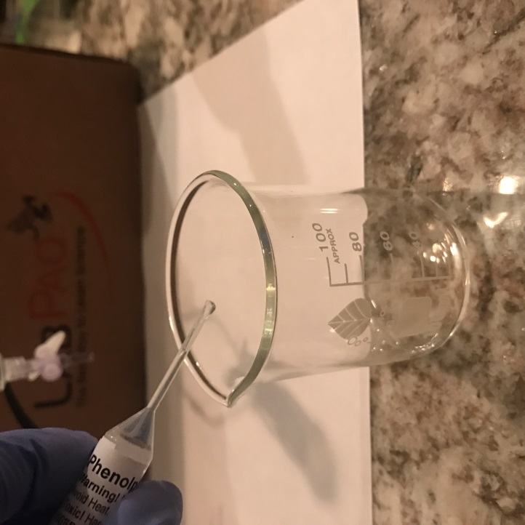
18. Carefully swirl the mixture in the beaker to ensure that the indicator is incorporated into the
vinegar; the solution will be colorless and clear.
19. Read the volume of NaOH in the titrator and record in Data Table 1 of your Lab Report
Assistant under “Initial NaOH Volume (mL),” next to “Trial 1”.
20. Open the stopcock and add 1 drop of NaOH to the colorless and clear vinegar sample in the
beaker. After the drop is added, gently swirl the beaker and observe the color for 5 seconds.
21. Continue adding NaOH to the beaker, 1 drop at a time, swirling and observing after each drop until the color changes to a bright-pink color for at least 5 seconds.
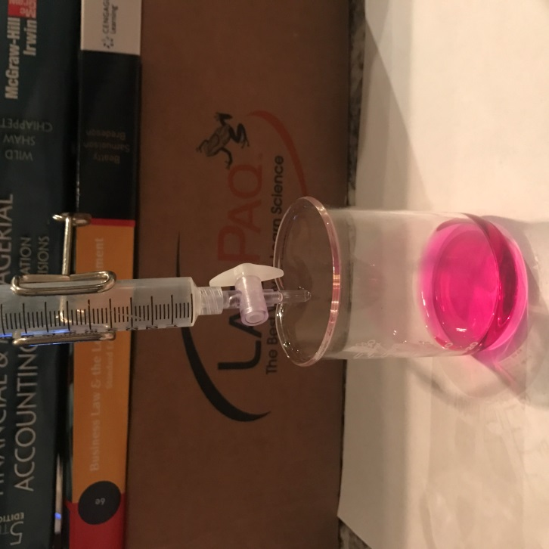
22. Read the volume of the NaOH solution remaining in the titrator and record this volume in
Data Table 1 under “Final NaOH Volume (mL)”, next to “Trial 1”.
23. Determine the total volume of NaOH used by subtracting the final NaOH volume from the
initial NaOH volume and record the total volume in Data Table 1.
24. Leave the titrator assembly intact. You will need it for a future titration in this experiment.
25. Pour the contents of the beaker down the drain and flush the drain with water. Thoroughly
wash the beaker with soap and water to remove all of the vinegar/NaOH/indicator solution
from the beaker. When the beaker is clean, rinse the beaker with distilled water and then
thoroughly dry.
26. Place the clean and thoroughly dry beaker back in the titration setup, under the titrator.
27. If necessary, add more NaOH to the titrator.
28. Repeat steps 15 through 23 one additional time (Trial 2).
29. Average the results from the 2 trials and record the average in Data Table 1.
30. Put the lid back on to the NaOH chemical bottle and return it to the kit for future use.
31. Flush the remaining phenolphthalein from the pipet down the drain with copious amounts of water. Wash all equipment with soap and water and return it to the kit for future use.
32. Using the following equation, determine the average concentration (moles per liter) of acetic acid (CH3COOH) present in your vinegar. Record the concentration in Data Table 2 of your Lab.
Report Assistant.
Data and Calculations:
Exercise 1: Determining the Concentration of Acetic Acid
Data Table 1. NaOH Titration Volume
 | Initial NaOH Volume (mL) | Final NaOH Volume (mL) | Total volume of NaOH used (mL)
Trial 1 | 9 mL | 0.2 | 8.8
Trial 2 | 9 mL | 0.3 | 8.9
 | Average Volume of NaOH Used (mL) : 8.8

Data Table 2. Concentration of CH₃COOH in Vinegar
Average volume of NaOH used (mL) | Concentration CH₃COOH in vinegar (mol/L) | % CH₃COOH in vinegar
8.8 | 72 mol/L | 83%

Molarity of Acid = {Molarity of Base x Volume of Base} / Volume of Acid: Show work here:
= 0.5 M NaOH x (Average Volume NaOH) / 5 mL Vinegar

% CH3COOH = (Molarity of Acid / 60 g/mole) x 100% =
Show work here:
Post Lab Questions:
- If the manufacturer of the vinegar used in the experiment stated that the vinegar contained 5.0% acetic acid, what would the percent error between your result and the manufacturer’s statement be? Show your work.

- What challenges would you encounter with the titration if you had used apple cider vinegar or balsamic vinegar as the analyte instead of distilled white vinegar?
Apple cider vinegar and balsamic vinegar are not clear like white vinegar so it might of not of given me the bright pink color I was looking for.

- How would your results have differed if the tip of the titrator was not filled with NaOH before the initial volume reading was recorded? Explain your answer.
The results would have been inaccurate because the tip contains about .5 mL of NaOH.

- How would your results have differed if you had over-titrated (added drops of NaOH to the analyte beyond the stoichiometric equivalence point)?
The results would have indicated that it took a greater amount of NaOH to neutralize the acetic acid in vinegar, which would of affected the percent composition.

- If a 7.0 mL sample of vinegar was titrated to the stoichiometric equivalence point with 7.5 mL of 1.5M NaOH, what is the mass percent of CH₃COOH in the vinegar sample?
I would need the density of vinegar to be able to find the mass percent.

- Why is it important to do multiple trials of a titration, instead of only one trial?
If I only did one trial I might have inaccurate results either from mechanical or calculation errors. Running multiple trials give you something to compare your last trial to.

- A student did not read the directions to the experiment properly and mixed up where to place the NaOH solution and the vinegar. He put the vinegar in the titrator and the measured amount of NaOH in the beaker. He then added a drop of the phenolphthalein to the solution in the beaker. Does the student need to empty out all of the solutions and start over again or can he go ahead and run the titration? If he runs the titration using the solutions as given above, what should he expect to see happen for results?
The student would have to empty out the solutions from the beaker and titrator and start over. I don’t think there would be a bright pink result after running the experiment this way.

Summary Paragraph:

